Homework_1

Sai Saketh Boyanapalli

August 29, 2017

# Packages required

library(moments)  
library(plyr)  
library(datasets)

## Question 1

# 1 Using R: Vectors

1. Create a vector with 10 numbers (3, 12, 6, -5, 0, 8, 15, 1, -10, 7) and assign it to x.

x <- c(3, 12, 6, -5, 0, 8, 15, 1, -10, 7)  
x

## [1] 3 12 6 -5 0 8 15 1 -10 7

1. Using the commands seq, min, and max with one line of code create a new vector y with 10 elements ranging from the minimum value of x to the maximum value of x.

y <- seq(min(x),max(x),length.out = 10)  
y

## [1] -10.000000 -7.222222 -4.444444 -1.666667 1.111111 3.888889  
## [7] 6.666667 9.444444 12.222222 15.000000

1. Compute the sum, mean, standard deviation, variance, mean absolute deviation, quartiles, and quintiles for x and y.

#sum of x and y  
sum(x)

## [1] 37

sum(y)

## [1] 25

#mean of x and y  
mean(x)

## [1] 3.7

mean(y)

## [1] 2.5

#standard deviation of x and y  
sd(x)

## [1] 7.572611

sd(y)

## [1] 8.41014

#variance of x and y  
var(x)

## [1] 57.34444

var(y)

## [1] 70.73045

#mean absolute deviation of x and y  
mad(x)

## [1] 5.9304

mad(y)

## [1] 10.29583

#quartiles of x and y  
quantile(x)

## 0% 25% 50% 75% 100%   
## -10.00 0.25 4.50 7.75 15.00

quantile(y)

## 0% 25% 50% 75% 100%   
## -10.00 -3.75 2.50 8.75 15.00

#quintiles of x and y  
quantile(x,probs = seq(0,1,0.2))

## 0% 20% 40% 60% 80% 100%   
## -10.0 -1.0 2.2 6.4 8.8 15.0

quantile(y,probs = seq(0,1,0.2))

## 0% 20% 40% 60% 80%   
## -1.000000e+01 -5.000000e+00 -1.665335e-15 5.000000e+00 1.000000e+01   
## 100%   
## 1.500000e+01

1. Create a new 7 element vector z by using R to randomly sample from x with replacement.

z<- sample(x,7, replace = TRUE)  
z

## [1] 3 1 8 1 7 6 0

1. Find a package (or packages) that provide the statistical measures skewness and kurtosis. Use the appropriate functions from the package to calculate the skewness and kurtosis of x.

The Skewness and Kurtosis functions are available in moments package.

skewness(x)

## [1] -0.3123905

kurtosis(x)

## [1] 2.355328

1. Use t.test() to compute a statistical test for differences in means between the vectors x and y. Are the differences in means signifcant?

t.test(x,y)

##   
## Welch Two Sample t-test  
##   
## data: x and y  
## t = 0.33531, df = 17.805, p-value = 0.7413  
## alternative hypothesis: true difference in means is not equal to 0  
## 95 percent confidence interval:  
## -6.324578 8.724578  
## sample estimates:  
## mean of x mean of y   
## 3.7 2.5

1. Sort the vector x and re-run the t-test as a paired t-test.

sorted_x <- sort(x)  
t.test(sorted_x,y,paired = TRUE)

##   
## Paired t-test  
##   
## data: sorted_x and y  
## t = 2.164, df = 9, p-value = 0.05868  
## alternative hypothesis: true difference in means is not equal to 0  
## 95 percent confidence interval:  
## -0.05440584 2.45440584  
## sample estimates:  
## mean of the differences   
## 1.2

1. Create a logical vector that identifies which numbers in x are negative.

neq_x <- x[x<0]

1. Use this logical vector to remove all entries with negative numbers from x. (Make sure to overwrite the vector x so that the new vector x has 8 elements!)

x <- x[!x %in% neq_x]  
x

## [1] 3 12 6 0 8 15 1 7

## Question 2

# Using R: Introductory data exploration

This exercise relates to the College data set, which can be found in the file .csv" in D2L. The file contains a number of variables for 777 different universities and colleges in the US.

# (a)

Use the read.csv() function to read the data into a data frame in R. Call the data frame college. Make sure that you have the directory set to the correct location for the data (or that the data is in the same directory as the RStudio project).

college <- read.csv("college.csv",header = TRUE)  
head(college)

## X Private Apps Accept Enroll Top10perc  
## 1 Abilene Christian University Yes 1660 1232 721 23  
## 2 Adelphi University Yes 2186 1924 512 16  
## 3 Adrian College Yes 1428 1097 336 22  
## 4 Agnes Scott College Yes 417 349 137 60  
## 5 Alaska Pacific University Yes 193 146 55 16  
## 6 Albertson College Yes 587 479 158 38  
## Top25perc F.Undergrad P.Undergrad Outstate Room.Board Books Personal PhD  
## 1 52 2885 537 7440 3300 450 2200 70  
## 2 29 2683 1227 12280 6450 750 1500 29  
## 3 50 1036 99 11250 3750 400 1165 53  
## 4 89 510 63 12960 5450 450 875 92  
## 5 44 249 869 7560 4120 800 1500 76  
## 6 62 678 41 13500 3335 500 675 67  
## Terminal S.F.Ratio perc.alumni Expend Grad.Rate  
## 1 78 18.1 12 7041 60  
## 2 30 12.2 16 10527 56  
## 3 66 12.9 30 8735 54  
## 4 97 7.7 37 19016 59  
## 5 72 11.9 2 10922 15  
## 6 73 9.4 11 9727 55

# (b)

# this will assisgn the row names of the data frame to college names  
rownames (college) <- college [,1]  
View (college )  
head(college)

## X Private Apps  
## Abilene Christian University Abilene Christian University Yes 1660  
## Adelphi University Adelphi University Yes 2186  
## Adrian College Adrian College Yes 1428  
## Agnes Scott College Agnes Scott College Yes 417  
## Alaska Pacific University Alaska Pacific University Yes 193  
## Albertson College Albertson College Yes 587  
## Accept Enroll Top10perc Top25perc F.Undergrad  
## Abilene Christian University 1232 721 23 52 2885  
## Adelphi University 1924 512 16 29 2683  
## Adrian College 1097 336 22 50 1036  
## Agnes Scott College 349 137 60 89 510  
## Alaska Pacific University 146 55 16 44 249  
## Albertson College 479 158 38 62 678  
## P.Undergrad Outstate Room.Board Books  
## Abilene Christian University 537 7440 3300 450  
## Adelphi University 1227 12280 6450 750  
## Adrian College 99 11250 3750 400  
## Agnes Scott College 63 12960 5450 450  
## Alaska Pacific University 869 7560 4120 800  
## Albertson College 41 13500 3335 500  
## Personal PhD Terminal S.F.Ratio perc.alumni  
## Abilene Christian University 2200 70 78 18.1 12  
## Adelphi University 1500 29 30 12.2 16  
## Adrian College 1165 53 66 12.9 30  
## Agnes Scott College 875 92 97 7.7 37  
## Alaska Pacific University 1500 76 72 11.9 2  
## Albertson College 675 67 73 9.4 11  
## Expend Grad.Rate  
## Abilene Christian University 7041 60  
## Adelphi University 10527 56  
## Adrian College 8735 54  
## Agnes Scott College 19016 59  
## Alaska Pacific University 10922 15  
## Albertson College 9727 55

# Now that we have assigned each row to the appropriate college name we can remove the column with college names  
college <- college [,-1]  
head(college)

## Private Apps Accept Enroll Top10perc  
## Abilene Christian University Yes 1660 1232 721 23  
## Adelphi University Yes 2186 1924 512 16  
## Adrian College Yes 1428 1097 336 22  
## Agnes Scott College Yes 417 349 137 60  
## Alaska Pacific University Yes 193 146 55 16  
## Albertson College Yes 587 479 158 38  
## Top25perc F.Undergrad P.Undergrad Outstate  
## Abilene Christian University 52 2885 537 7440  
## Adelphi University 29 2683 1227 12280  
## Adrian College 50 1036 99 11250  
## Agnes Scott College 89 510 63 12960  
## Alaska Pacific University 44 249 869 7560  
## Albertson College 62 678 41 13500  
## Room.Board Books Personal PhD Terminal  
## Abilene Christian University 3300 450 2200 70 78  
## Adelphi University 6450 750 1500 29 30  
## Adrian College 3750 400 1165 53 66  
## Agnes Scott College 5450 450 875 92 97  
## Alaska Pacific University 4120 800 1500 76 72  
## Albertson College 3335 500 675 67 73  
## S.F.Ratio perc.alumni Expend Grad.Rate  
## Abilene Christian University 18.1 12 7041 60  
## Adelphi University 12.2 16 10527 56  
## Adrian College 12.9 30 8735 54  
## Agnes Scott College 7.7 37 19016 59  
## Alaska Pacific University 11.9 2 10922 15  
## Albertson College 9.4 11 9727 55

# (c)

1. summary() function will give us the summary of the data

summary(college)

## Private Apps Accept Enroll Top10perc   
## No :212 Min. : 81 Min. : 72 Min. : 35 Min. : 1.00   
## Yes:565 1st Qu.: 776 1st Qu.: 604 1st Qu.: 242 1st Qu.:15.00   
## Median : 1558 Median : 1110 Median : 434 Median :23.00   
## Mean : 3002 Mean : 2019 Mean : 780 Mean :27.56   
## 3rd Qu.: 3624 3rd Qu.: 2424 3rd Qu.: 902 3rd Qu.:35.00   
## Max. :48094 Max. :26330 Max. :6392 Max. :96.00   
## Top25perc F.Undergrad P.Undergrad Outstate   
## Min. : 9.0 Min. : 139 Min. : 1.0 Min. : 2340   
## 1st Qu.: 41.0 1st Qu.: 992 1st Qu.: 95.0 1st Qu.: 7320   
## Median : 54.0 Median : 1707 Median : 353.0 Median : 9990   
## Mean : 55.8 Mean : 3700 Mean : 855.3 Mean :10441   
## 3rd Qu.: 69.0 3rd Qu.: 4005 3rd Qu.: 967.0 3rd Qu.:12925   
## Max. :100.0 Max. :31643 Max. :21836.0 Max. :21700   
## Room.Board Books Personal PhD   
## Min. :1780 Min. : 96.0 Min. : 250 Min. : 8.00   
## 1st Qu.:3597 1st Qu.: 470.0 1st Qu.: 850 1st Qu.: 62.00   
## Median :4200 Median : 500.0 Median :1200 Median : 75.00   
## Mean :4358 Mean : 549.4 Mean :1341 Mean : 72.66   
## 3rd Qu.:5050 3rd Qu.: 600.0 3rd Qu.:1700 3rd Qu.: 85.00   
## Max. :8124 Max. :2340.0 Max. :6800 Max. :103.00   
## Terminal S.F.Ratio perc.alumni Expend   
## Min. : 24.0 Min. : 2.50 Min. : 0.00 Min. : 3186   
## 1st Qu.: 71.0 1st Qu.:11.50 1st Qu.:13.00 1st Qu.: 6751   
## Median : 82.0 Median :13.60 Median :21.00 Median : 8377   
## Mean : 79.7 Mean :14.09 Mean :22.74 Mean : 9660   
## 3rd Qu.: 92.0 3rd Qu.:16.50 3rd Qu.:31.00 3rd Qu.:10830   
## Max. :100.0 Max. :39.80 Max. :64.00 Max. :56233   
## Grad.Rate   
## Min. : 10.00   
## 1st Qu.: 53.00   
## Median : 65.00   
## Mean : 65.46   
## 3rd Qu.: 78.00   
## Max. :118.00

?pairs # using ? before a function shows us the documentation for it.

## starting httpd help server ... done

pairs(college[,1:10],college)

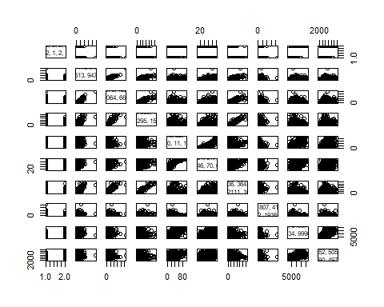 (iii)

# This function creates a boxplot for no of OutState students in private colleges  
plot(college$Private,college$Outstate,main = "OutState students in Private College", xlab = "Private",ylab = "Outstate" )

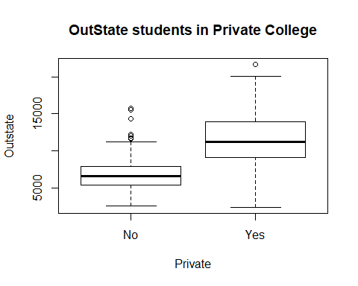 iv. Using the following bit of code you will create a new qualitative variable, called Elite by binning the Top10perc variable. That is, Elite will classify the universities into two groups based on whether or not the proportion of students coming from the top 10% of their high school classes exceeds 50%. Add comments to each line below explaining what the corresponding code is doing and then run the code.

Elite <- rep ("No", nrow(college )) # this line creates a list with value 'NO' with the length set to no of rows in college. using rep function.   
Elite [college$Top10perc >50] <- "Yes" # In this line the college with top10percent greater than 50, the elite value is set to "Yes"  
Elite <- as.factor (Elite) #The values in Elite are factored to two levels   
college <- data.frame(college ,Elite) # Elite is addes as one of the variables to college data frame.

1. Use the summary() function to see how many elite universities there are.

summary(college$Elite)

## No Yes   
## 699 78

we can see there are 78 elite students in total. vi.

plot(college$Elite,college$Outstate,main = "Outstate elite students", xlab = "Elite students", ylab = "OutState")

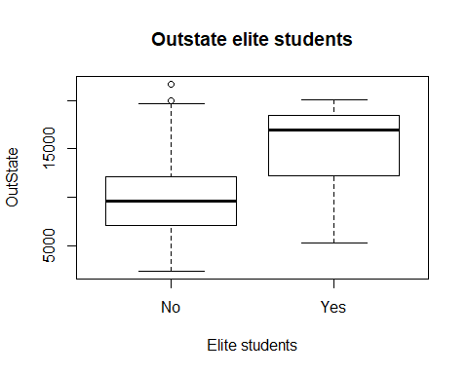 we can clearly see that there are more outstate elite students.

1. Use the hist() function to produce some histograms with diering numbers of bins for a few of the quantitative variables.

par(mfrow=c(2,2)) # this command will divide plot window into 4 sections  
hist(college$Outstate,breaks = 10) # this will create a Histogram.  
hist(college$Apps,breaks = 5) # breaks is used to set no of bins.  
hist(college$Accept,breaks = 15)  
hist(college$Top10perc,breaks = 6)

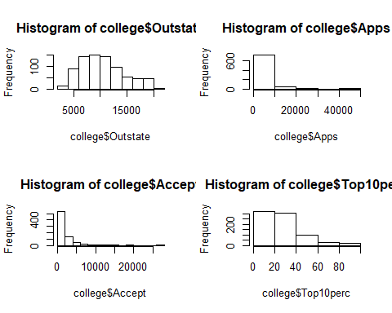 ##Question 3 #Using R: Manipulating data in data frames (a) Load the data frame baseball in the plyr package. Use ?baseball to get information about the data set and definitions for the variables.

data("baseball") # data is used to load a specific data set  
?baseball

1. You will calculate the on base percentage for each player, but first clean up the data:

* Before 1954, sacrifice flies were counted as part of sacrifice hits, so for players before 1954,sacrifice flies (i.e. the variable sf) should be set to 0.

baseball$sf[baseball$year < 1954] <- 0

* Hit by pitch (the variable hbp) is often missing { set these missings to 0.

baseball$hbp[is.na(baseball$hpb)] <- 0

## Warning in is.na(baseball$hpb): is.na() applied to non-(list or vector) of  
## type 'NULL'

* Exclude all player records with fewer than 50 at bats (the variable ab).

baseball <- baseball[-c(baseball$ab < 50), ]

1. Compute on base percentage in the variable obp according to the formula:

obp <-((baseball$h + baseball$bb + baseball$hbp)/(baseball$ab + baseball$bb + baseball$hbp + baseball$sf))   
baseball <- data.frame(baseball,obp)

1. Sort the data based on the computed obp and print the year, player name, and on base percentage for the top five records based on this value.

Sorted_obp <- baseball[order(-obp) , ] # (-obp indicates decreasing order)  
top_five <- Sorted_obp[1:5, ]  
top_five[,c("year","id","obp")]

## year id obp  
## 6074 1894 brownpe01 1  
## 13924 1913 griffcl01 1  
## 14537 1914 griffcl01 1  
## 16076 1916 davisha01 1  
## 17429 1918 haineje01 1

## Question 4

# Using R: aggregate() function

1. Load the quakes data from the datasets package.

data("quakes")

1. Plot the recorded earthquake magnitude against the earthquake depth using the plot command.

plot(quakes$depth,quakes$mag,main ="earthquake magnitude against the earthquake depth", xlab = "depth",ylab = "magnitude")

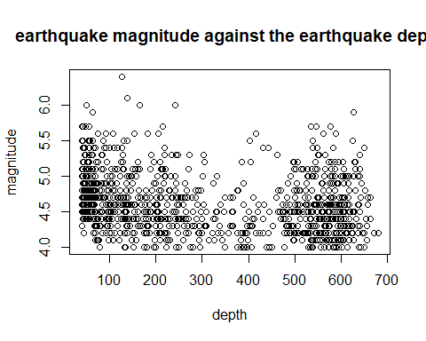 (c) Use aggregate to compute the average earthquake depth for each magnitude level. Store these results in a new data frame named quakeAvgDepth.

quakeAvgDepth <- aggregate(quakes$depth ~ quakes$mag,quakes, FUN = mean)

1. Rename the variables in quakeAvgDepth to something meaningful.

colnames(quakeAvgDepth) <- c("Magnitude of Earthquake","corresponding_Average_Depth")  
head(quakeAvgDepth)

## Magnitude of Earthquake corresponding_Average_Depth  
## 1 4.0 410.0652  
## 2 4.1 412.4000  
## 3 4.2 389.8778  
## 4 4.3 357.9294  
## 5 4.4 307.1188  
## 6 4.5 333.6729

1. Plot the magnitude vs. the average depth.

plot(quakeAvgDepth$corresponding_Average_Depth,quakeAvgDepth$`Magnitude of Earthquake`,main="Magnitude vs. the Average Depth of Quake",xlab="Average Depth",ylab="Magnitude")

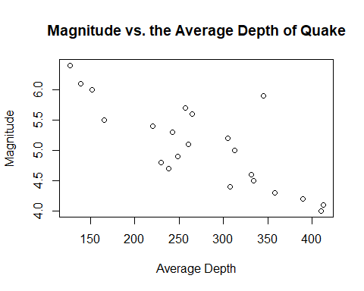 (f) From the two plots, do you think there is a relationship between earthquake depth and magnitude?

From the Two graphs we can see that the depth of the quake decreases with the increase in magnitude.